Team 1 Open Source Air Quality Monitoring

Week 19: May 15th - May 22

Sponsor: Dr. [David Burnett](mailto:dburnett@pdx.edu)

Advisor: Dr. John Acken

Team Members: [Adam Dezay](mailto:adezay@pdx.edu), [Manuel Garcia](mailto:manga2@pdx.edu), [Brandon Hippe](mailto:bhippe@pdx.edu), Mercedes Newton

**Team Review:**

* Team 3d printed the enclosure in the epl and decided to utilize laser cutting as opposed to 3d printing in interest of selecting a more price efficient option
* Discussed starting on documentation soon as opposed to waiting until June 1st
* Discussed increasing number of batteries, based on initial power consumption testing, 1 will not be enough for 1 year battery life. Enclosure will have space for 4 18650 cells, so ultimately it's a matter of cost vs measurement rate. Measurement periods calculated using current power measurements are shown in table two.
* Discussed PCB revisions. New PCB order will be sent out this week, if necessary.

**Individual Review**

Adam Dezay:

Started on the final report rough draft as well as finishing up the BOM and manual. Updated Wiki

Manuel Garcia:

Built 2 different PCB configuration, one with high side mosfet and the other with low side mosfets. Having issues with power draw still in both configs, attempting to troubleshoot solution.

Brandon Hippe:

Started on power consumption testing. Figured out high idle current issue, for some reason setting one of the GPIOs to high on the MSP430 consumes ~10mA of current, even though the pin isn’t connected to anything. Tried connecting a load (used 1.8 kΩ resistor) to see if that would bring the current back to expected levels, but that just added to the current used for setting the pin high. Upon further testing, it turns out setting pin 8 high draws ~10.2 mA of current and setting pin 32 high draws ~29.7 mA of current, but all other pins do not have any noticeable current draw, so those will be used instead. Also worked on laser cutting model, and did first test cuts.

Mercedes Newton:

Reviewed the first 3d printed model and discussed steps moving forward. Switching focus from enclosure to assembly and documentation.

**Gantt Chart and Timeline Updates:**

Below is both the timeline of the projected project progress for spring term. Figure 1 represents the gantt chart for the term with expected completion dates beginning March 25th. All specific dates for the upcoming term are specified in the table below.

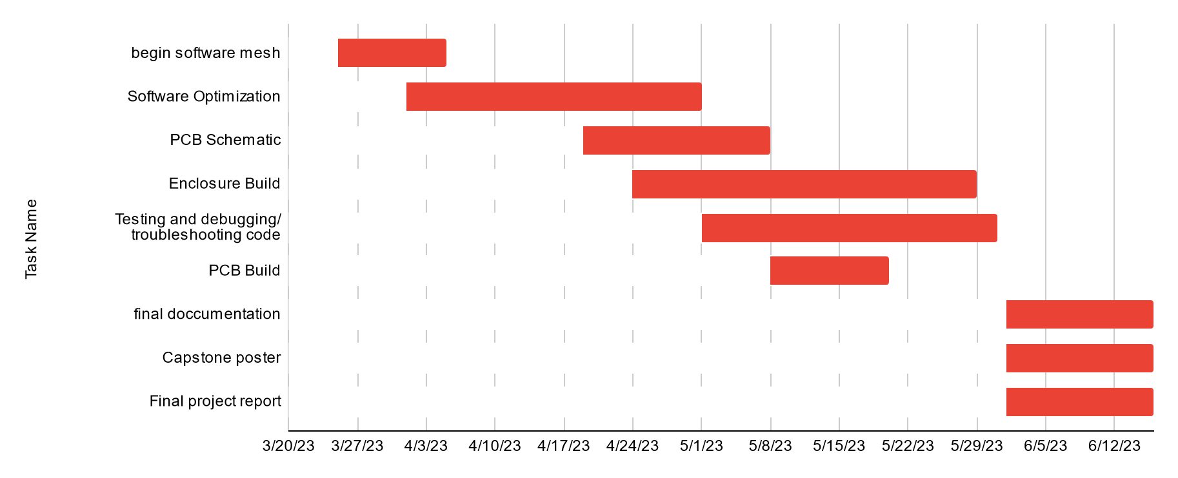

Figure One: Gantt chart for spring term (first task starts 3/25/2013)

| Task Name | Start date | End date |
| --- | --- | --- |
| Begin software mesh | 3/25/2023 | 4/5/2023 |
| Software Optimization | 4/1/2023 | 5/1/2023 |
| PCB Schematic | 4/19/2023 | 5/8/2023 |
| Enclosure Build | 4/24/2023 | 5/29/2023 |
| Testing and debugging/ troubleshooting code | 5/1/2023 | 5/31/2023 |
| PCB Build | 5/8/2023 | 5/20/2023 |
| final documentation | 6/1/2023 | 6/16/2023 |
| Capstone poster | 6/1/2023 | 6/16/2023 |
| Final project report | 6/1/2023 | 6/16/2023 |

Table One: Tasks for spring term with expected completion dates *completion dates subject to change*

|  | 4 Cells, sensor sleep modes | 4 Cells, full sensor shutoff | 3 Cells, sensor sleep modes | 3 Cells, full sensor shutoff | 2 Cells, full sensor shutoff |
| --- | --- | --- | --- | --- | --- |
| PM2.5 | 90 min | 87 min | 160 min | 140 min | 325 min |
| CO2 | 33 min | 26 min | 74 min | 40 min | 95 min |
| Anemometer | No Data Yet | No Data Yet | No Data Yet | No Data Yet | No Data Yet |
| Battery life (W/O Anemometer) | 366.37 days | 365.68 days | 367.61 days | 365.33 days | 365.19 days |

Table Two: Sensor measurement periods and battery life estimates for 2-4 cells. Full sensor shutoff numbers are just estimates; haven't tested power consumption with shutoff transistors yet.